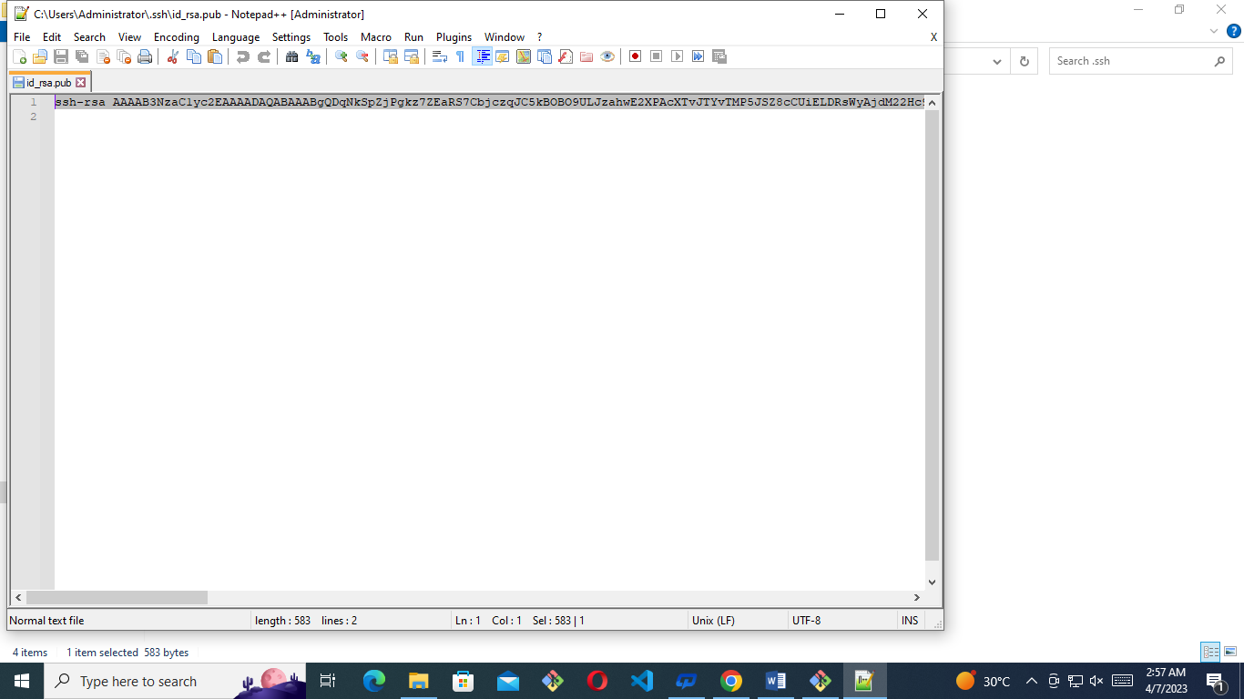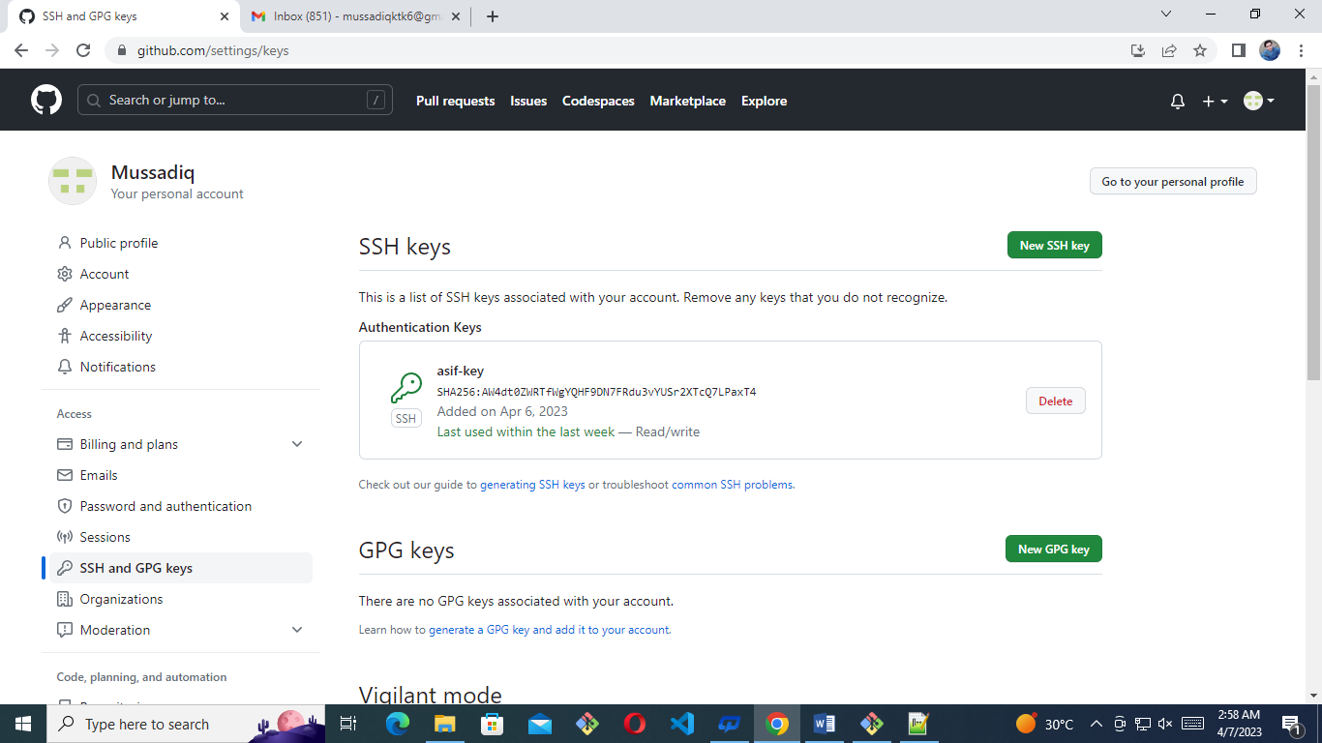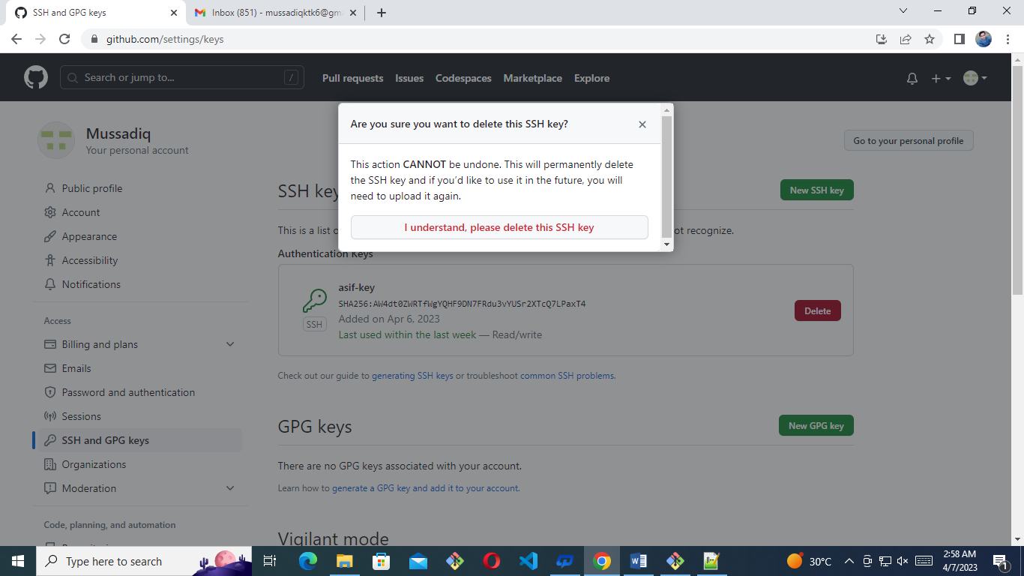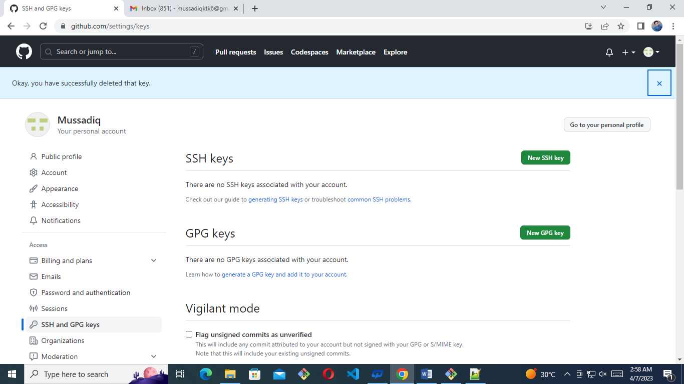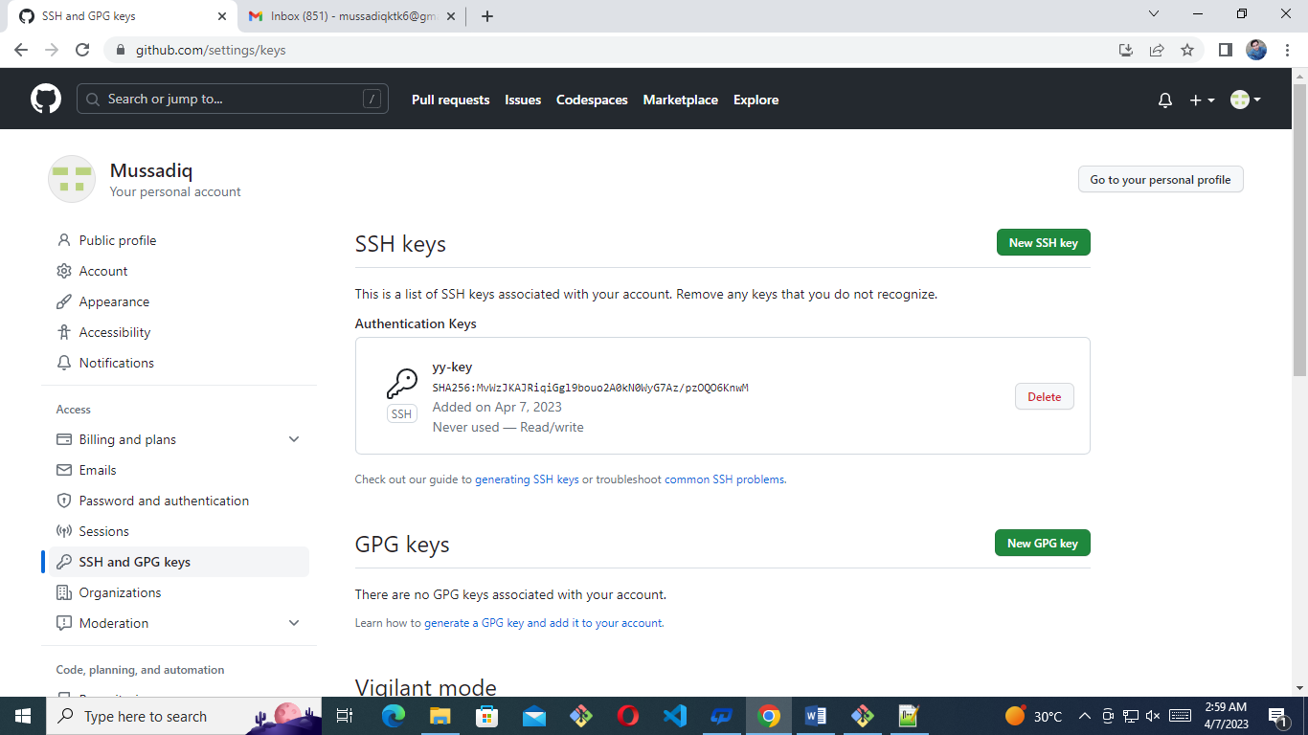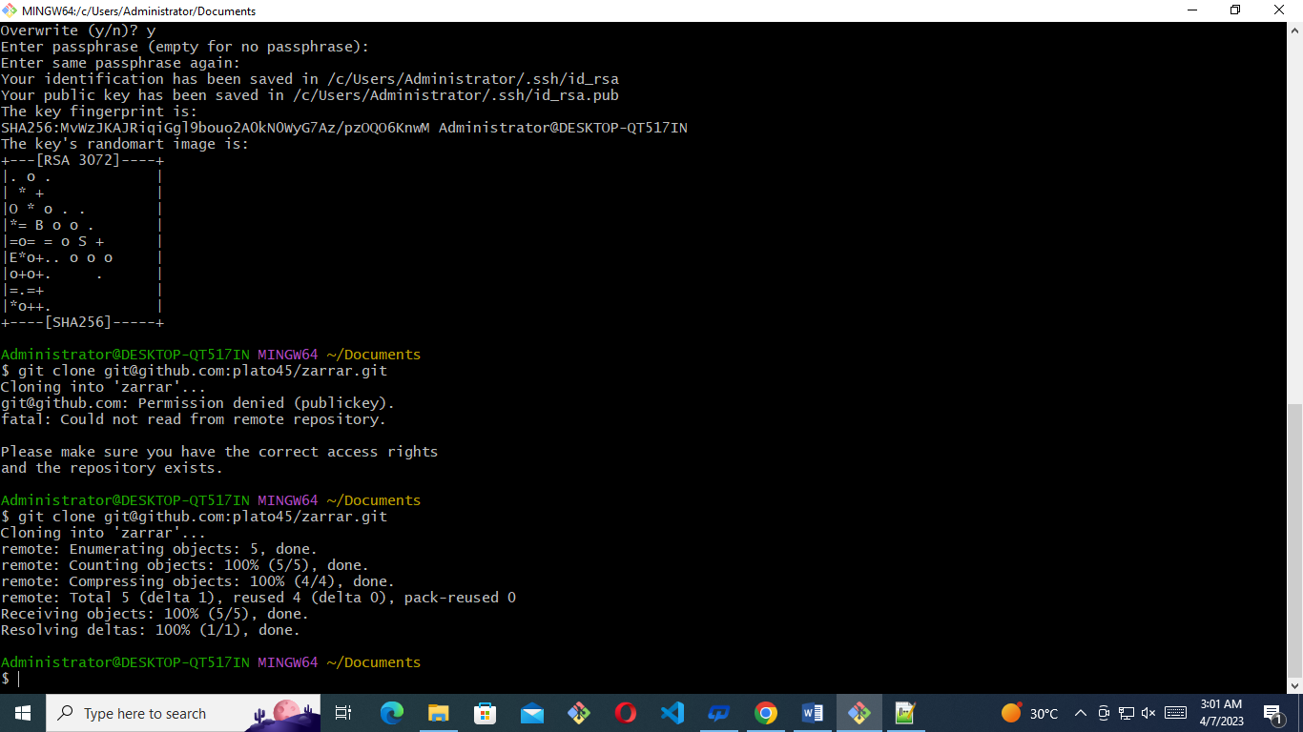

Administrator@DESKTOP-QT517IN MINGW64 ~

$ pwd

/c/Users/Administrator

Administrator@DESKTOP-QT517IN MINGW64 ~

$ cd Documents/

Administrator@DESKTOP-QT517IN MINGW64 ~/Documents

$ ls

'Custom Office Templates'/ 'My Pictures'@ user1/

'My Music'@ 'My Videos'@ user2/

Administrator@DESKTOP-QT517IN MINGW64 ~/Documents

$ cd user1

Administrator@DESKTOP-QT517IN MINGW64 ~/Documents/user1 (master)

$ ls

index.html style.css

Administrator@DESKTOP-QT517IN MINGW64 ~/Documents/user1 (master)

$ touch uuu.html

Administrator@DESKTOP-QT517IN MINGW64 ~/Documents/user1 (master)

$ ls

index.html style.css uuu.html

Administrator@DESKTOP-QT517IN MINGW64 ~/Documents/user1 (master)

$ git status

On branch master

Untracked files:

(use "git add <file>..." to include in what will be committed)

uuu.html

nothing added to commit but untracked files present (use "git add" to track)

Administrator@DESKTOP-QT517IN MINGW64 ~/Documents/user1 (master)

$ git add .

Administrator@DESKTOP-QT517IN MINGW64 ~/Documents/user1 (master)

$ git commit -m 'uuu.html'

[master 6f13333] uuu.html

1 file changed, 0 insertions(+), 0 deletions(-)

create mode 100644 uuu.html

Administrator@DESKTOP-QT517IN MINGW64 ~/Documents/user1 (master)

$ git status

On branch master

nothing to commit, working tree clean

Administrator@DESKTOP-QT517IN MINGW64 ~/Documents/user1 (master)

$ git branch

\* master

Administrator@DESKTOP-QT517IN MINGW64 ~/Documents/user1 (master)

$ git branch farh

Administrator@DESKTOP-QT517IN MINGW64 ~/Documents/user1 (master)

$ git branch

farh

\* master

Administrator@DESKTOP-QT517IN MINGW64 ~/Documents/user1 (master)

$ git checkout farh

Switched to branch 'farh'

Administrator@DESKTOP-QT517IN MINGW64 ~/Documents/user1 (farh)

$ ls

index.html style.css uuu.html

Administrator@DESKTOP-QT517IN MINGW64 ~/Documents/user1 (farh)

$ git log

commit 6f1333305331a055b544b8f21c918737ca6ae703 (HEAD -> farh, master)

Author: plato45 <mussadiqktk6@gmail.com>

Date: Thu Apr 6 21:13:31 2023 -0700

uuu.html

commit 6cf1621d5e62c97ca8cde9d28b4cddc6201cc680 (origin/master)

Author: plato45 <mussadiqktk6@gmail.com>

Date: Wed Apr 5 21:32:21 2023 -0700

added

Administrator@DESKTOP-QT517IN MINGW64 ~/Documents/user1 (farh)

$ ^C

Administrator@DESKTOP-QT517IN MINGW64 ~/Documents/user1 (farh)

$ ^C

Administrator@DESKTOP-QT517IN MINGW64 ~/Documents/user1 (farh)

$ git cherry-pick 6f1333305331a055b544b8f21c918737ca6ae703

The previous cherry-pick is now empty, possibly due to conflict resolution.

If you wish to commit it anyway, use:

git commit --allow-empty

Otherwise, please use 'git cherry-pick --skip'

On branch farh

You are currently cherry-picking commit 6f13333.

(all conflicts fixed: run "git cherry-pick --continue")

(use "git cherry-pick --skip" to skip this patch)

(use "git cherry-pick --abort" to cancel the cherry-pick operation)

nothing to commit, working tree clean

Administrator@DESKTOP-QT517IN MINGW64 ~/Documents/user1 (farh|CHERRY-PICKING)

$ git status

On branch farh

You are currently cherry-picking commit 6f13333.

(all conflicts fixed: run "git cherry-pick --continue")

(use "git cherry-pick --skip" to skip this patch)

(use "git cherry-pick --abort" to cancel the cherry-pick operation)

nothing to commit, working tree clean

Administrator@DESKTOP-QT517IN MINGW64 ~/Documents/user1 (farh|CHERRY-PICKING)

$

